**write a Dockerfile and build the Docker image for this Static Application same application run using the Kubernetes POD**

1 apt update -y

2 docker --version

3 apt install docker.io

4 docker version

5 systemctl start docker

6 systemctl status docker

7 vi Dockerfile

8 docker build -t static-app .

9 docker run -d -p 8080:80 static-app

10 docker login

11 docker build -t your-dockerhub-vinu12/static-app:latest .

12 docker push your-dockerhub-vinu12/static-app:latest

13 docker push vinu12/application/static-app:latest

14 docker login

15 docker tag static-app your-dockerhub-vinu12/static-app:lates

16 docker push vinu12/application/static-app:latest

17 docker images

18 docker tag static-app vinu12/application/static-app:latest

19 docker push vinu12/application/static-app:latest

20 docker push vinu12/application:tagname

21 docker push vinu12/application:static-app

22 sudo curl -LO https://storage.googleapis.com/minikube/releases/latest/minikube-linux-amd64

23 ll

24 sudo mv minikube-linux-amd64 /usr/local/bin/minikube

25 sudo chmod +x /usr/local/bin/minikube

26 sudo minikube version

27 sudo apt install curl wget apt-transport-https -y

28 sudo curl -LO "https://dl.k8s.io/release/$(curl -L -s https://dl.k8s.io/release/stable.txt)/bin/linux/amd64/kubectl"

29 sudo kubectl version --client

30 sudo curl -LO "https://dl.k8s.io/$(curl -L -s https://dl.k8s.io/release/stable.txt)/bin/linux/amd64/kubectl.sha256"

31 sudo echo "$(cat kubectl.sha256) kubectl" | sha256sum --check

32 sudo install -o root -g root -m 0755 kubectl /usr/local/bin/kubectl

33 sudo kubectl version --client

34 sudo kubectl version --client --output=yaml

35 sudo minikube start --driver=docker --force

36 kubectl run pod1 --image=nginx

37 vi vinod.yml

38 kubectl create -f vinod.yml

39 kubectl get pods

40 vi deployment.yml

41 kubectl create -f deployment.yml

42 kubectl apply -f deployment.yml

43 kubectl get pods

44 kubectl get deployments

45 vi service.yml

46 kubectl apply -f myapp-service.yaml

47 kubectl apply -f service.yaml

48 service.yaml

49 vi service.yaml

50 kubectl apply -f service.yaml

51 kubectl get svc service

52 kubectl get svc

53 kubectl get pods -w -o wide

Push to the jipfile in github

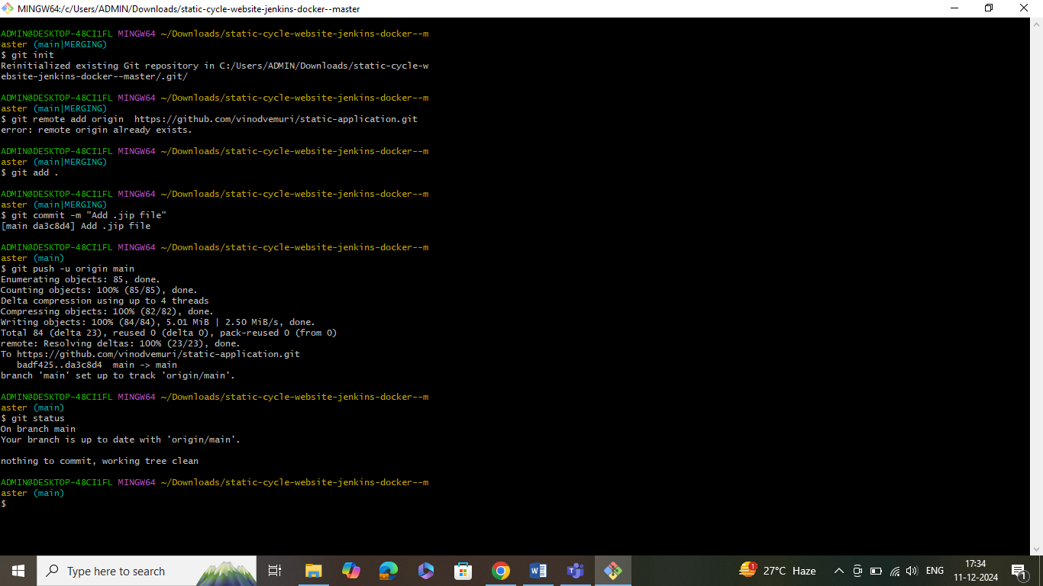

Now write the docker file and access the application

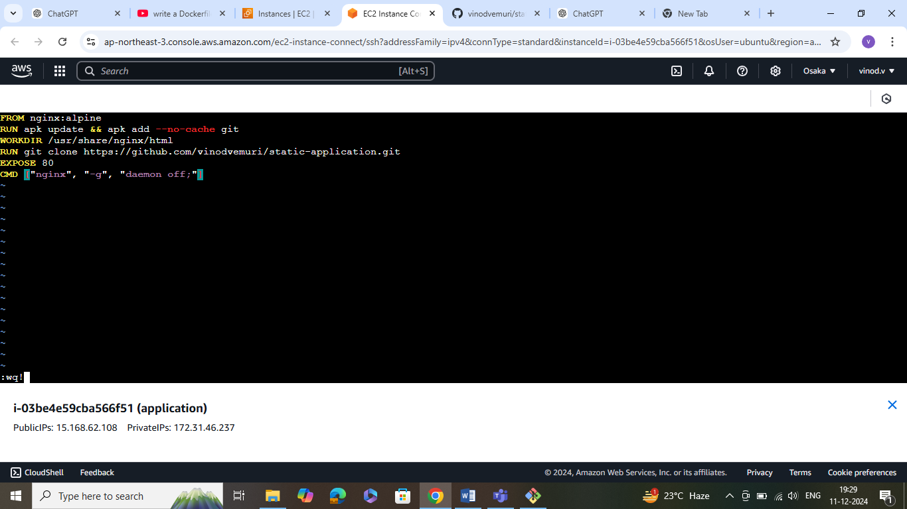

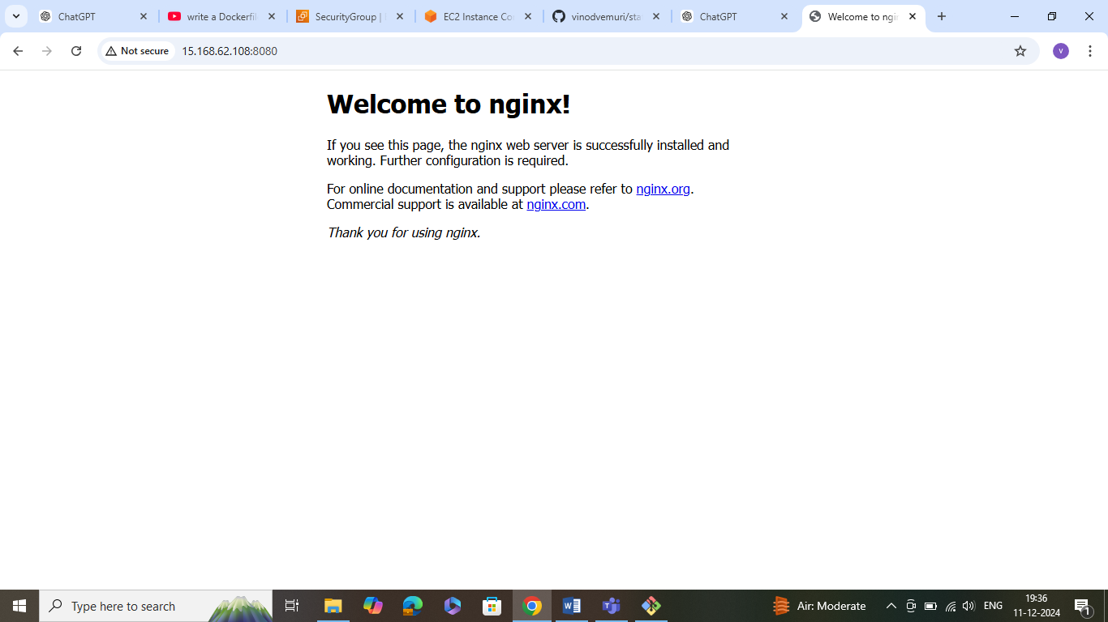

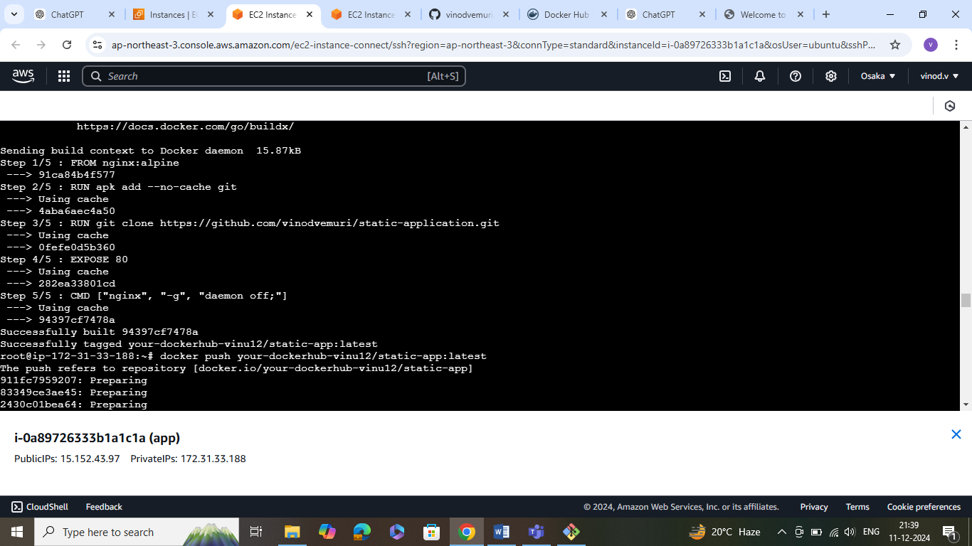

Single pod creation

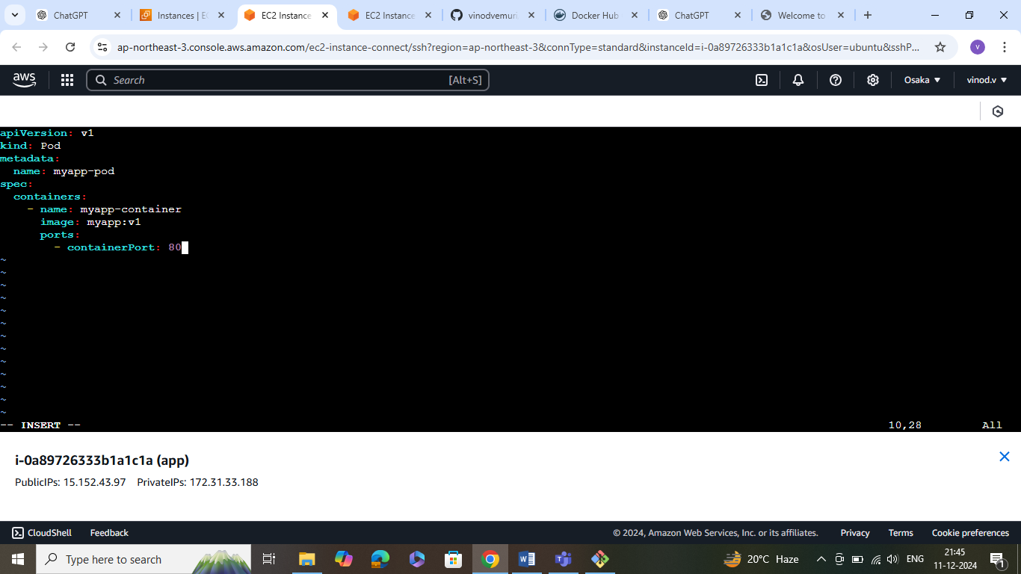

Deployment creation

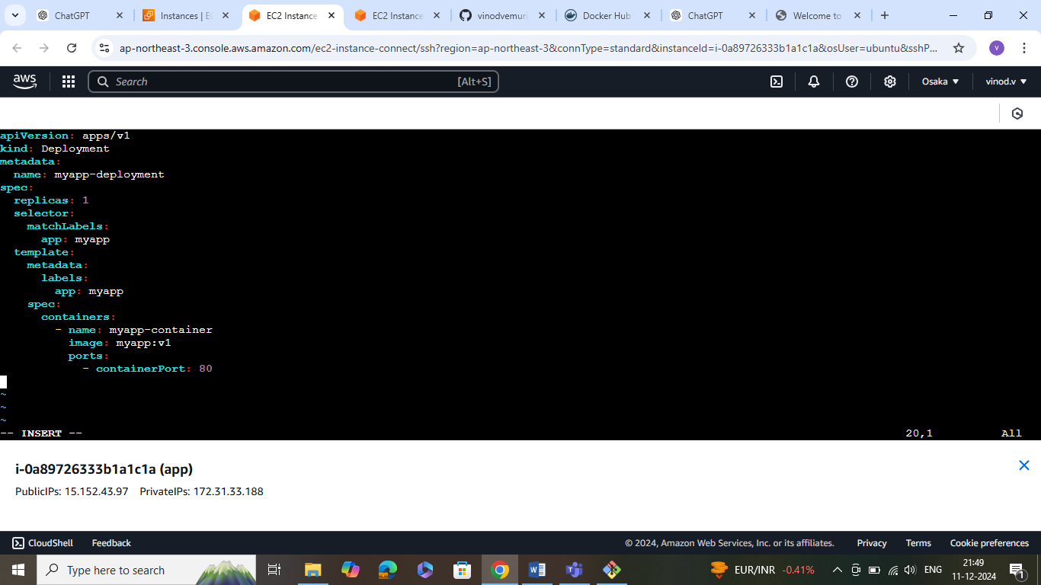

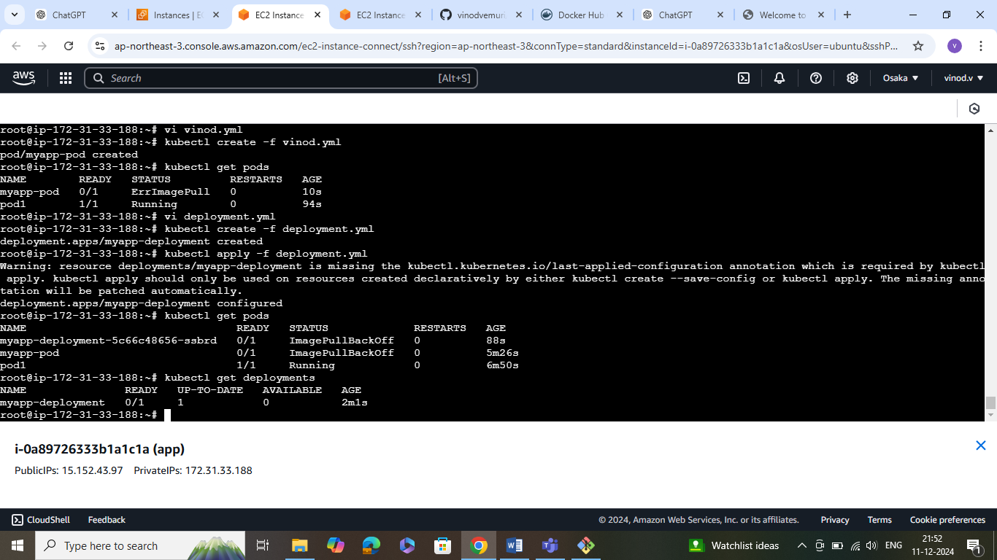

Now service creation

